Supplementary Material for ”The Effects of Group-Based Community Interventions to Support the Social Reintegration of Marginalized Adults with Mental Illness: A Systematic Review and Meta-Analysis”
Table of Contents
Potential biases in the review process 1
Descriptive statistics for studies reporting mental health outcomes 2
Detailed forest plots 6
Sensitivity analysis 8
Reference 10

Potential biases in the review process
We performed a comprehensive electronic database search, combined with grey literature searching, and hand searching of key journals. All citations were screened by two independent screeners from the review team, and one review author (NTD) assessed all included studies against the inclusion criteria. We believe that nearly all the publicly available studies on the effects of group-based interventions for marginalized adults suffering from both mental illness and social problems within the OECD countries were identified during the review process. However, 35 references were not obtained in full text. This can potentially be a source of bias in the review. Similarly, it can have induced bias that we were not able to include all studies, as we could not calculate the effect size for 12 studies. However, as illustrated in Figure 21, we did not find any indication that the 12 excluded studies reached a different conclusion than our review.

Fig. S1 | Bar plot illustrating directions of overall conclusions from the 12 studies without effect sizes
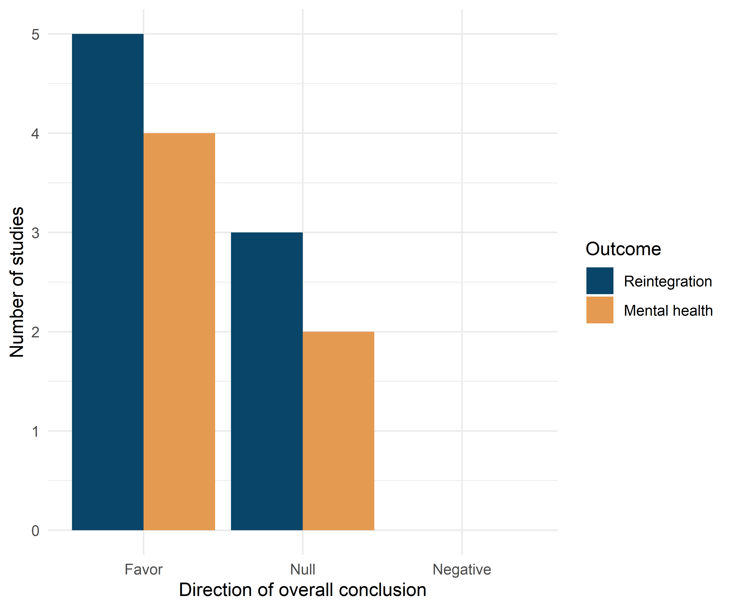

Descriptive statistics for studies reporting mental health outcomes
Tables S1 and S2 below present descriptive statistics for studies reporting mental health outcomes.
Table S1 | Descriptive percentages for the included studies for mental health outcomes
Characteristics | Studies (j) | Effects (k) | % Studies | % Effects
Context
Australia | 9 | 22 | 21.4 | 15.3
Austria | 1 | 2 | 2.4 | 1.4
Canada | 2 | 3 | 4.8 | 2.1
Korea | 1 | 5 | 2.4 | 3.5
Finland | 2 | 3 | 4.8 | 2.1
Germany | 4 | 26 | 9.5 | 18.1
Ireland | 1 | 6 | 2.4 | 4.2
Italy | 2 | 4 | 4.8 | 2.8
Japan | 1 | 2 | 2.4 | 1.4
Netherlands | 2 | 4 | 4.8 | 2.8
Norway | 2 | 5 | 4.8 | 3.5
Spain | 2 | 21 | 4.8 | 14.6
Turkey | 1 | 4 | 2.4 | 2.8
UK | 3 | 7 | 7.1 | 4.9
US | 9 | 30 | 21.4 | 20.8
Outcome measure
Anxiety | 9 | 14 | 21.4 | 9.7
Depression | 20 | 37 | 47.6 | 25.7
General mental health | 29 | 72 | 69.0 | 50.0
Symptoms of psychosis | 7 | 21 | 16.7 | 14.6
Diagnosis in sample
Schizophrenia | 7 | 14 | 16.7 | 9.7
Other | 35 | 130 | 83.3 | 90.3
Intervention type
CBT | 12 | 49 | 28.6 | 34.0
Other | 31 | 95 | 73.8 | 66.0
Preregistration status
Not preregistered | 22 | 62 | 52.4 | 43.1
Preregistered | 20 | 82 | 47.6 | 56.9
Outlet
Journal article | 42 | 144 | 100.0 | 100.0
Research design
QES | 8 | 17 | 19.0 | 11.8
RCT | 34 | 127 | 81.0 | 88.2
Test type
Clinician-rated measure | 14 | 41 | 33.3 | 28.5
Self-reported | 33 | 103 | 78.6 | 71.5
Analysis strategy
ITT | 18 | 69 | 42.9 | 47.9
TOT | 24 | 75 | 57.1 | 52.1
Control group
Individual treatment | 2 | 3 | 4.8 | 2.1
TAU | 28 | 108 | 66.7 | 75.0
TAU with Waiting-list | 9 | 26 | 21.4 | 18.1
Waiting-list only | 3 | 7 | 7.1 | 4.9
Overall risk of bias
Low | 10 | 36 | 23.8 | 25.0
Some concerns/Moderate | 20 | 79 | 47.6 | 54.9
Serious/High | 13 | 29 | 31.0 | 20.1
Timing of measurement
Short-term measure (< 52 weeks) | 42 | 144 | 100.0 | 100.0
Effect size metric
Pre-posttest adj. ES | 42 | 144 | 100.0 | 100.0
Handles multilevel structure
No | 40 | 140 | 95.2 | 97.2
Yes | 2 | 4 | 4.8 | 2.8
Note: ES = Effect size, ITT = Intention-To-Treat; TOT; Treatment-On-the-Treated; QES = Quasi-Experimental Design (non-randomized); RCT = Randomized Controlled Trial; TAU = Treatment as usual; CBT = cognitive behavioral therapy.

Table S2 | Descriptive means of included studies reporting mental health outcomes

Characteristics | Studies (j) | Effects (k) | $$Median_{j}$$ | $$Mean_{j}$$ | $$SD_{j}$$ | Range
Sample characteristics
Raw treatment sample size | 42 | 144 | 28.00 | 54.00 | 59.40 | 7-315
Raw control sample size | 42 | 144 | 29.00 | 51.00 | 58.30 | 9-316
Total sample size | 42 | 144 | 60.00 | 111.00 | 125.00 | 16-631
Effective treatment sample size | 42 | 144 | 20.00 | 33.00 | 33.90 | 4-175
Effective control sample size | 42 | 144 | 19.00 | 30.00 | 33.20 | 5-176
Total effective sample size | 42 | 144 | 38.00 | 67.00 | 71.50 | 10-351
Average age in studies | 42 | 144 | 39.70 | 39.60 | 9.30 | 22-67
% Males | 41 | 143 | 46.30 | 45.30 | 23.50 | 0-81
Intervention characteristics
Average group size | 26 | 92 | 7.00 | 7.10 | 1.60 | 4-10
Total number of sessions | 41 | 143 | 13.00 | 21.60 | 22.50 | 3-104
Sessions per week | 41 | 143 | 1.00 | 1.30 | 1.50 | 0-10.5
Duration (in weeks) | 42 | 144 | 12.00 | 19.30 | 17.50 | 4-78
Measurement timing
After end of intervention (in weeks) | 42 | 144 | 1.00 | 10.70 | 16.60 | 0-52
From baseline (in weeks) | 42 | 144 | 22.00 | 30.10 | 27.40 | 6-130
Methodological features
Pre-posttest correlation (empirically computed)ª | 9 | 18 | 0.48 | 0.51 | 0.17 | 0.12-0.76
Note.
ª Computed at the effect size level

Detailed forest plots
Figure S2 and S3 present more outcome-specific forest plot, including specific weight attributed to each effect size within the given study and the overall average effect size.
Fig. S2 | Effect size forest plot with dependent effect sizes for social reintegration outcomes
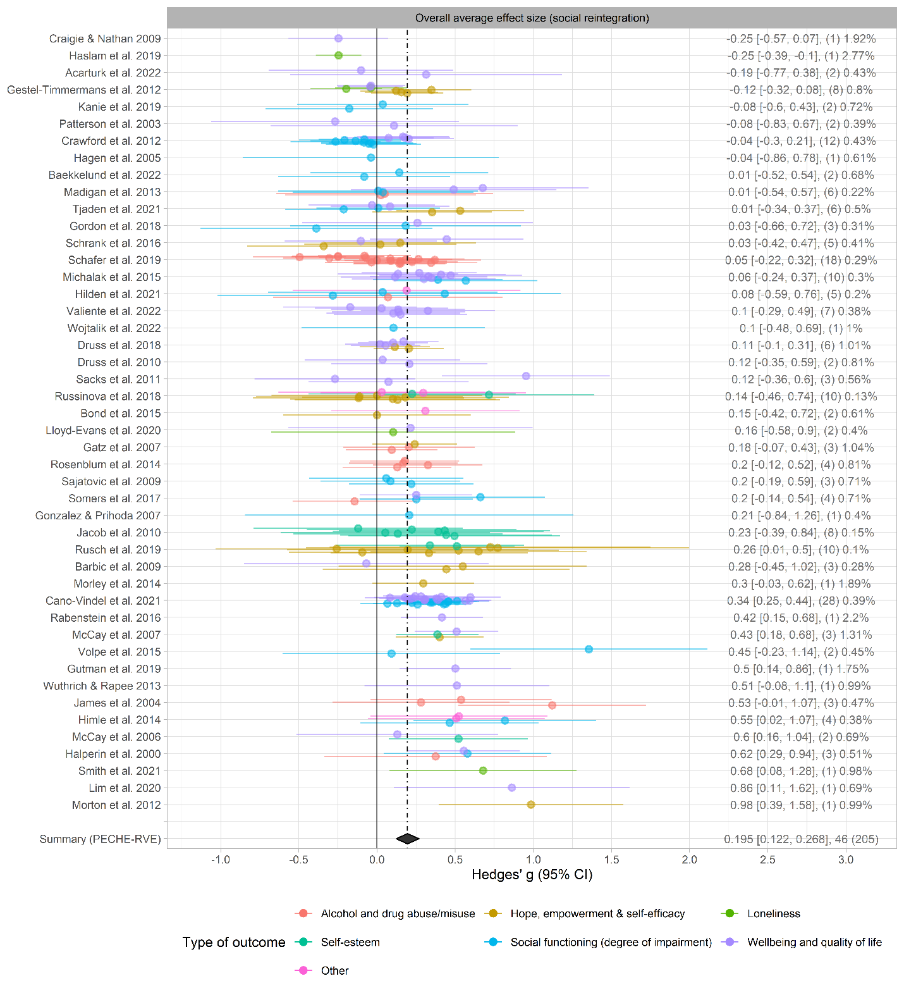
Note: The number of effect size estimates is in parentheses. The percentages indicate the weight given to each effect size within the given study. Studies are ordered by the study mean effect size obtained from fitting the within-study effect sizes to a univariate meta-analysis model, as suggested by Fernández-Castilla, Declercq, et al.¹ The dashed line indicates the overall average effect size (g = .195), and the diamond indicates the 95% confidence interval from the fitted PECHE-RVE model.
Fig. S3 | Effect size forest plot with dependent effect sizes for mental health outcomes
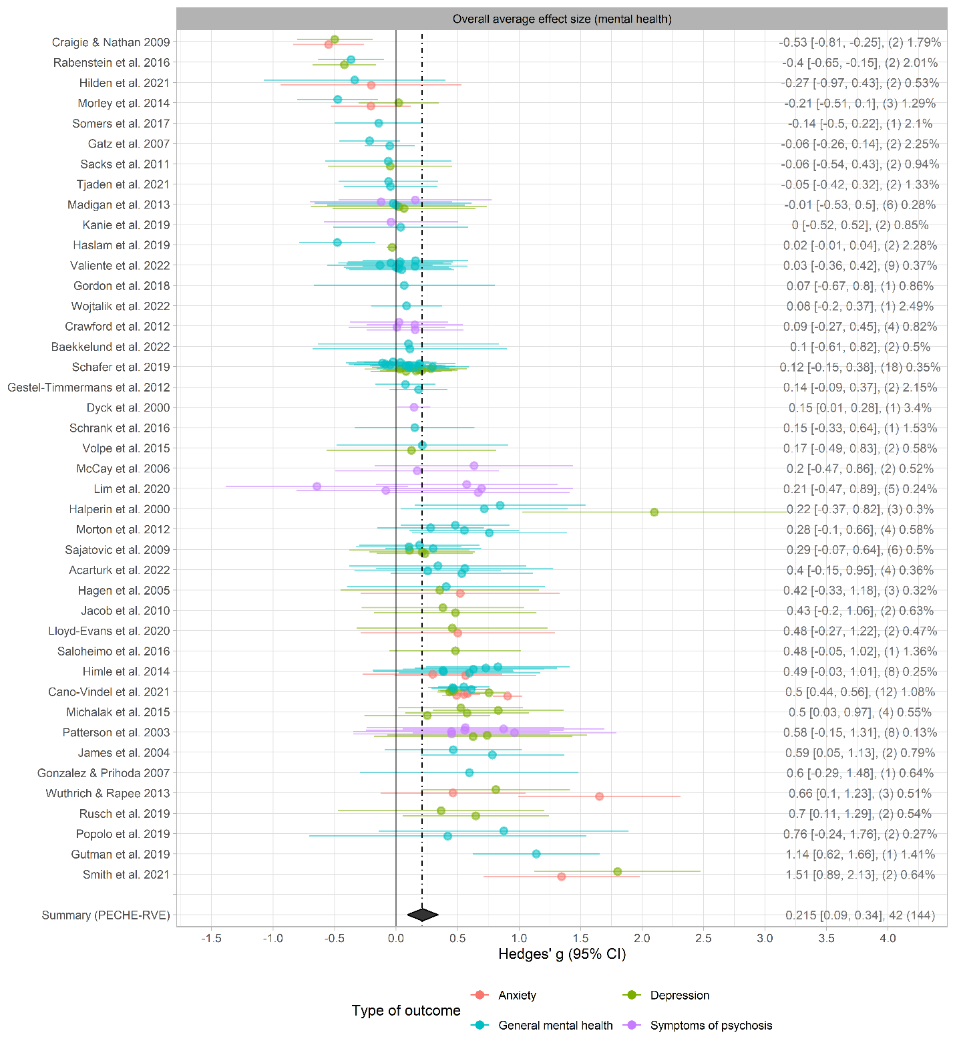
Note: The number of effect size estimates is in parentheses. The percentages indicate the weight given to each effect size within the given study. Studies are ordered by the study mean effect size obtained from fitting the within-study effect sizes to a univariate meta-analysis model, as suggested by Fernández-Castilla, Declercq, et al.¹ The dashed line indicates the overall average effect size (g = .215), and the diamond indicates the 95% confidence interval from the fitted PECHE-RVE.

Sensitivity analysis
Figures S4-S5 present sensitivity analyses while changing effect size calculation assumptions and inclusion criteria for social reintegration and mental health outcomes, respectively.
Fig. S4 | Sensitivity analyses changing effect size calculation assumptions and inclusion criteria for social reintegration outcomes
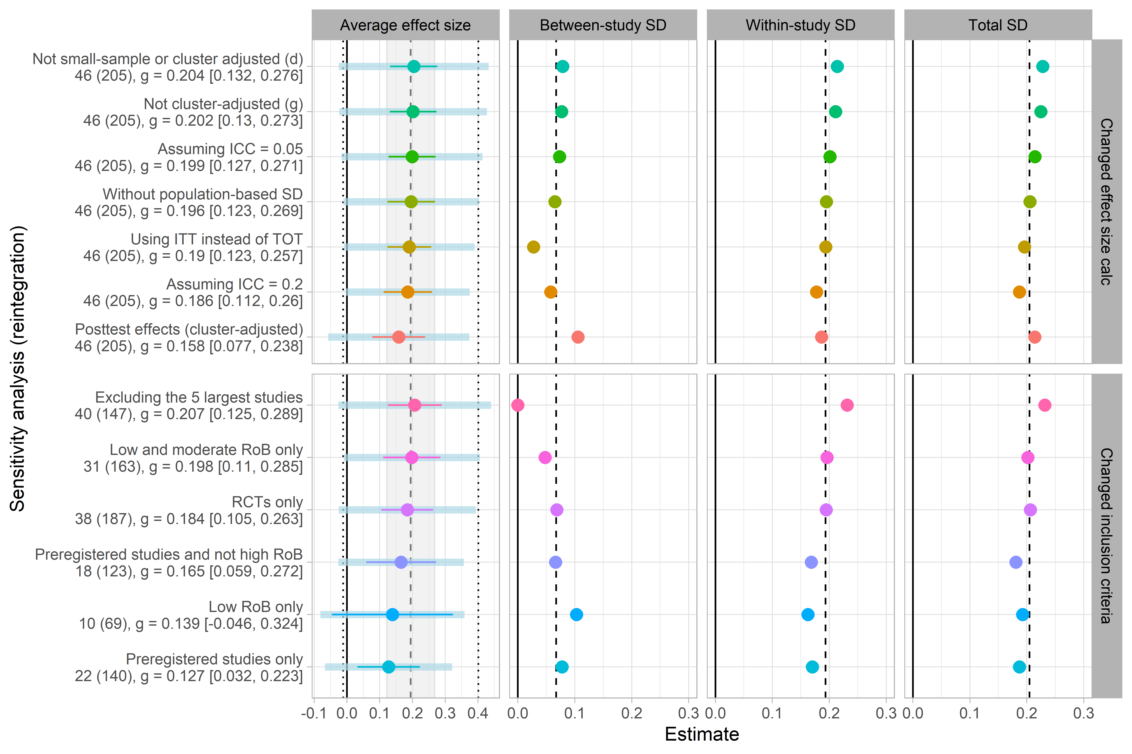
Note: Dashed lines indicate the estimated values from the main analysis. The gray shading in the first column represents the width of the confidence interval from the main analysis, while the point lines indicate the re-estimated confidence intervals. Dotted lines indicate the 67% prediction interval estimated from the main analysis, and the blue bands in the first column represent the re-estimated 67% prediction intervals.

Fig. S5 | Sensitivity analyses changing effect size calculation and inclusion criteria for mental health outcomes
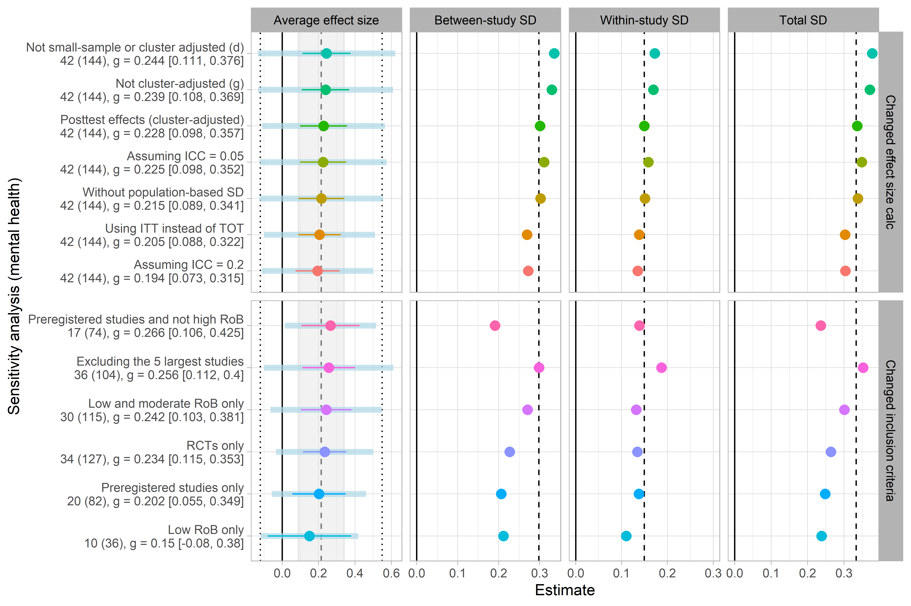
Note: Dashed lines indicate the estimated values from the main analysis. The gray shading in the first column represents the width of the confidence interval from the main analysis, while the point lines indicate the reestimated confidence intervals. Dotted lines indicate the 67% prediction interval estimated from the main analysis, and the blue bands in the first column represent the re-estimated 67% prediction intervals.

Reference
1. Fernández-Castilla, B. et al. Visual representations of meta-analyses of multiple outcomes: Extensions to forest plots, funnel plots, and caterpillar plots. Methodology 16, 299–315 (2020).

